Political Juggernauts: A Quantitative Analysis of

Candidates in the 2019 LOK Sabha Elections

1.Introduction

1.1. Overview:

The LOK Sabha is composed of Representatives of people chosen by direct election on the basis of Universal Adult Suffrage. The constitution of India allows for a maximum of 550 members in the House, with 530 members representing the states and 20 representing the Union Territories. The 17th LOK Sabha was formed by the members elected in the 2019 Indian general election. Elections, all across India, were conducted in seven phase from 11 April 2019 to 19 May 2019 by the election Commission of the India.

1.2. Purpose

The Bharatiya Janata party received 37.36% of the vote, the highest vote share by a political party since the 1989 general election, and won 303 seats, further

increasing its substantial majority. In addition, the BJP –

led National Democratic Alliance(NDA) won 353 seats.

2.Problem Definition & Design Thinking

2.1 Empathy Map

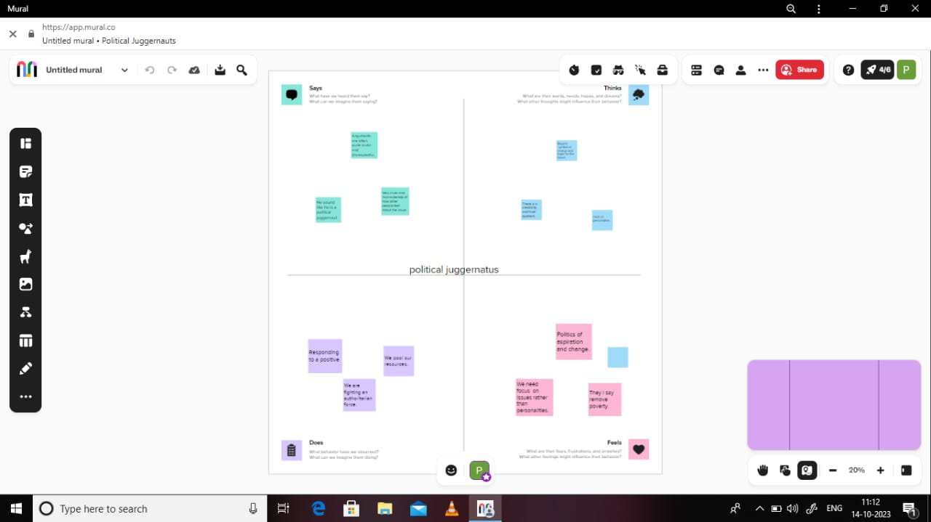

2.2 Ideation & Brainstorming Map

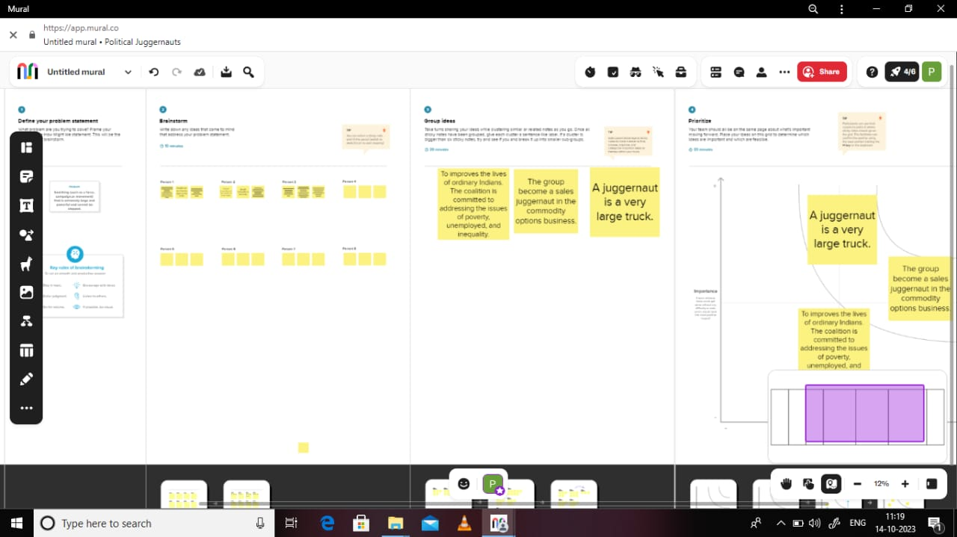

3.Result

3.1.KPI’s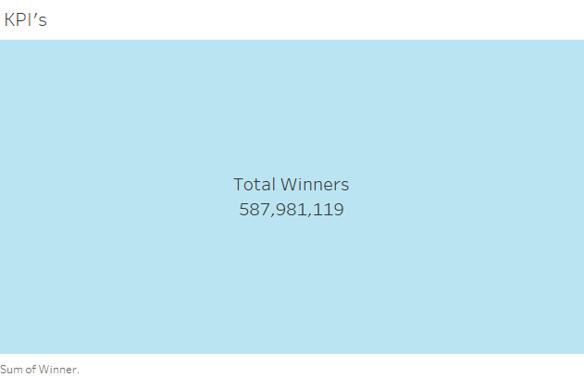

A KPI dashboard displays key performance

indicators in interactive charts and graphs, allowing for

quick, organized review and analysis.

3.2. constituency wise Winners and Electors

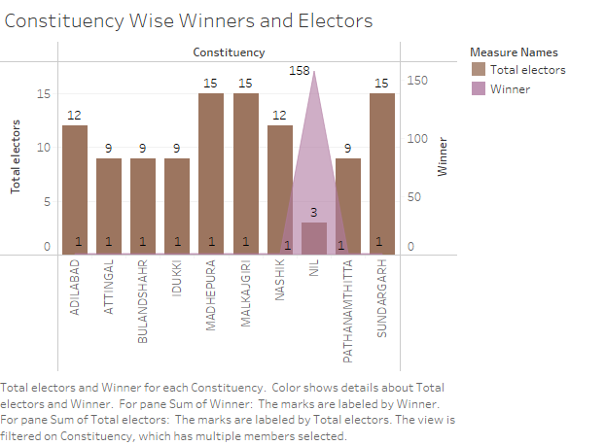

3.3. State wise winner

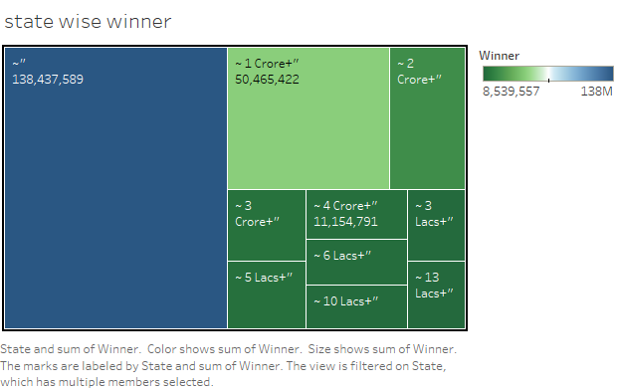

3.4. State wise General votes and Postal votes

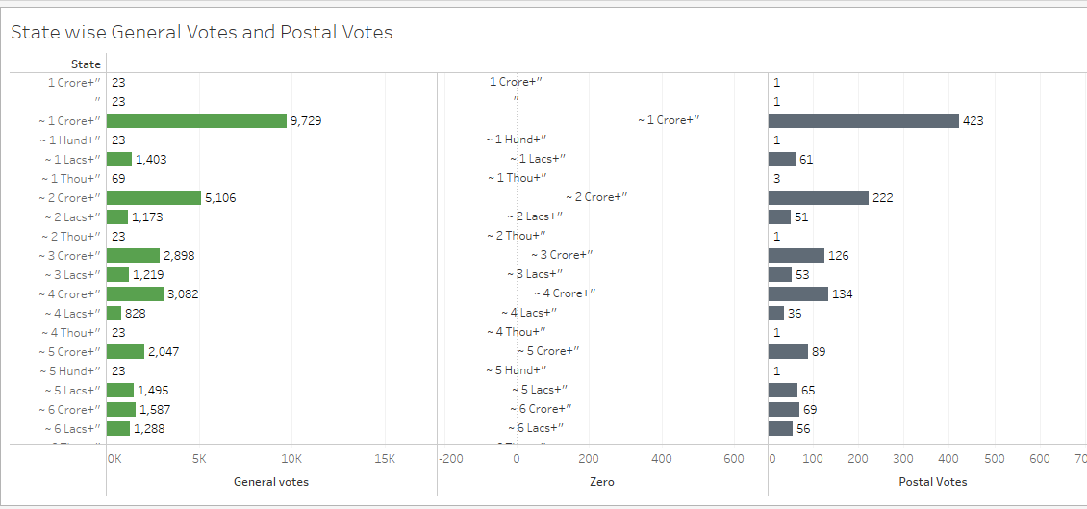

3.5. State wise Criminal Cases

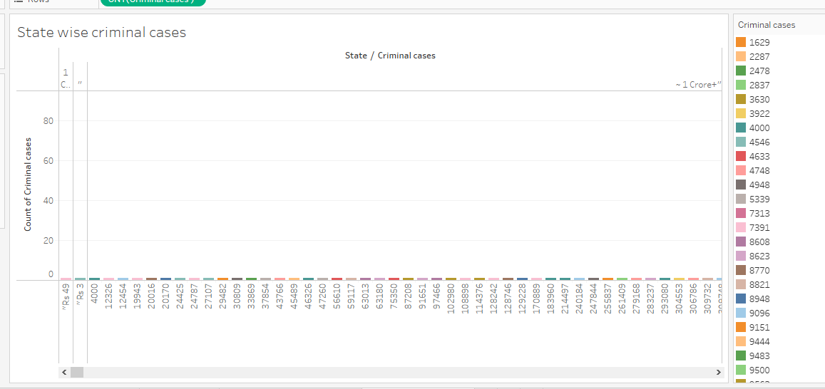

3.6. Party wise winner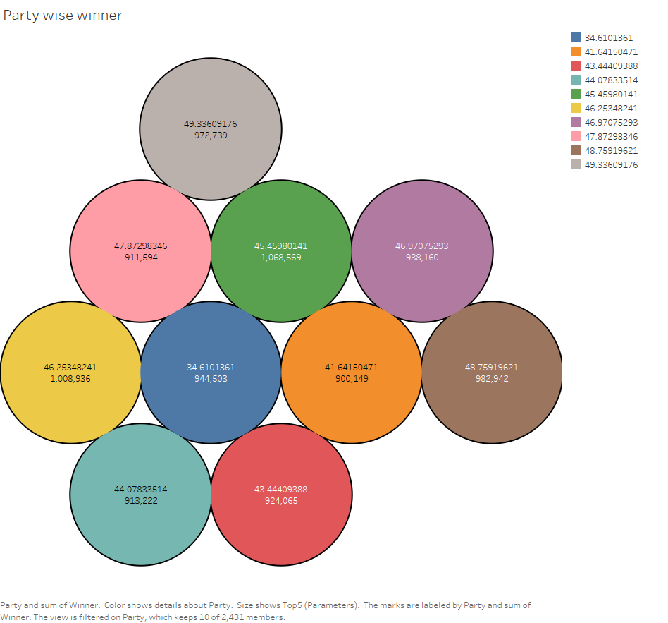

4. Advantages & Disadvantages

\*Political parties are able to present political information to the voting population in a manner that is readily understandable.

\*political parties provide balance through the accommodation of various interests and opinions.

\*political parties might have a selfish propaganda that could hurt national interest.

\*political parties could create factionalism.

5. APPLICATION

Data Analysis provide a political with useful information to support their decision making process,

It can be applied to analyze general votes and postal votes, state wise winner, criminal cases, winners and electors.

6.CONCLUTION

Finally this political data analytics explains how to

Improve the political juggernaut and analyze it and votes, female or male.